Chapter 12, Solution 86.

For the single-phase three-wire system in Fig. 12.77, find currents I_{aA}, I_{bB}, and I_{nN}.

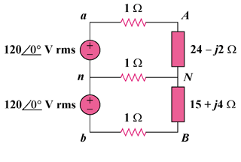

Figure 12.77
For Prob. 12.86.

Solution

Consider the circuit shown below.

1

1

1200 V rms
+

a

1

24 – j2

15 + j4

1200 V rms
+

I₂

I₁

n

b

A

N

B

For the two meshes,
(1)
(2)

In matrix form,

, ,

